APK Build Process

Prerequisites: You should have a local MDK client setup ready.
https://developers.sap.com/tutorials/cp-mobile-dev-kit-build-client.html

- Follow SAP docs step to create APK https://help.sap.com/doc/f53c64b93e5140918d676b927a3cd65b/Cloud/en-US/docs-en/guides/getting-started/mdk/custom-client/release-custom-client.html

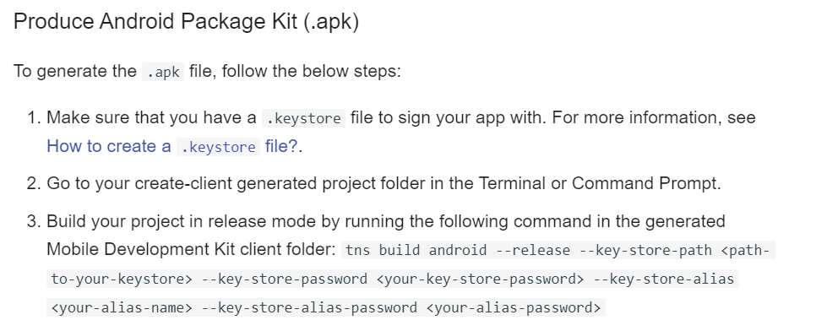

- Creating a keystore from https://docs.oracle.com/cd/E19509-01/820-3503/ggfen/index.html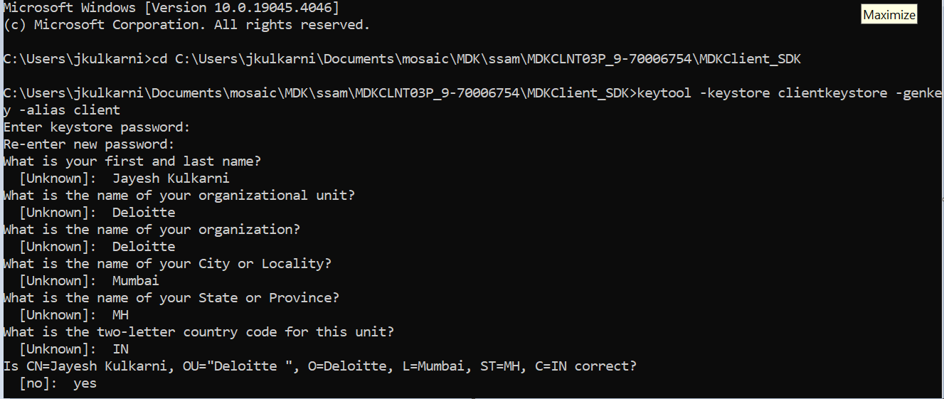
- Extending the validity of keystore to 20,000 days.

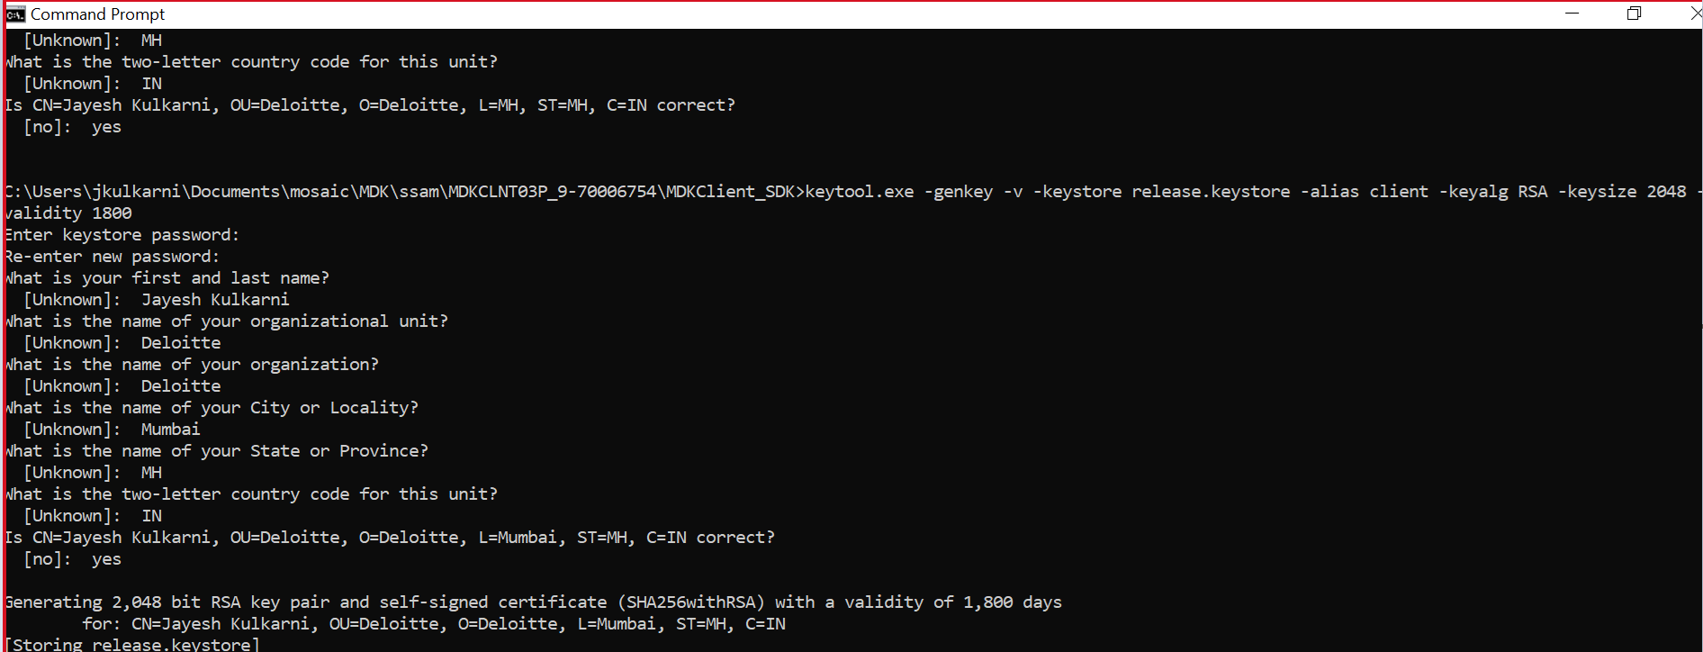

- Build using command tns build android --release --key-store-path C:\Users\jkulkarni\Documents\mosaic\MDK\ssam\MDKCLNT03P_9-70006754\MDKClient_SDK\release.keystore --key-store-password M0sa!c@2210 --key-store-alias client --key-store-alias-password M0sa!c@2210

